# Spring Data Exam

# Deutsche Autohäuser

*Car dealers in Germany are a key part of the country’s strong automotive industry. They range from official brand dealerships offering new cars and services to independent sellers focused on used vehicles. German dealers are known for professionalism, strict regulation, and a wide selection of both domestic and imported cars.*

## Functionality Overview

The application should be able to easily **import** hard-formatted data and **support functionalities** for also **exporting** the imported data. The application is called – **Deutsche Autohaeser**.

Look at the pictures below to see what must happen:

* The home page before importing anything:



* The import JSON page before importing anything:

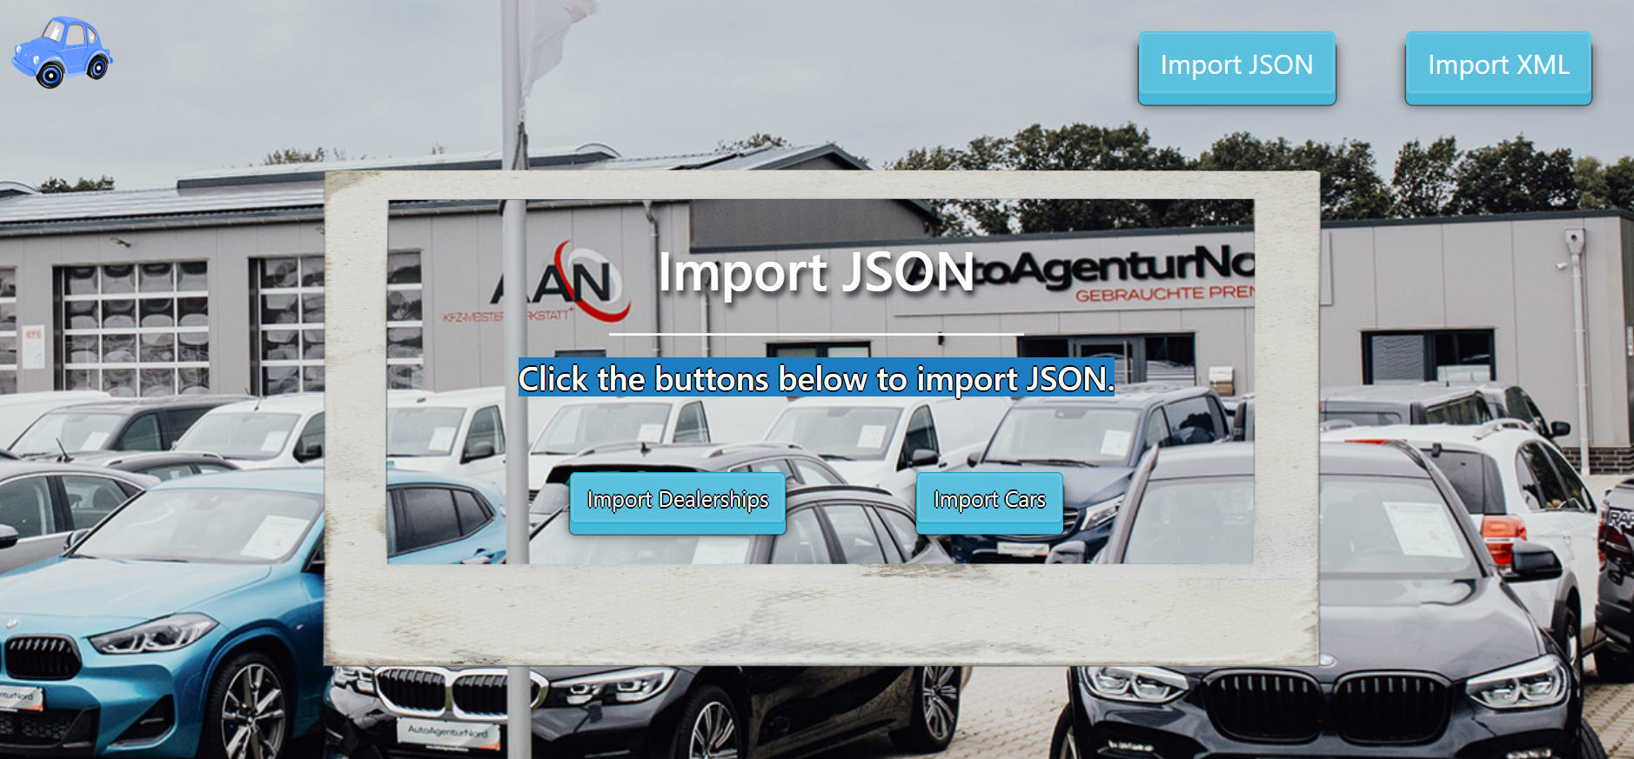

* Import the dealerships first:

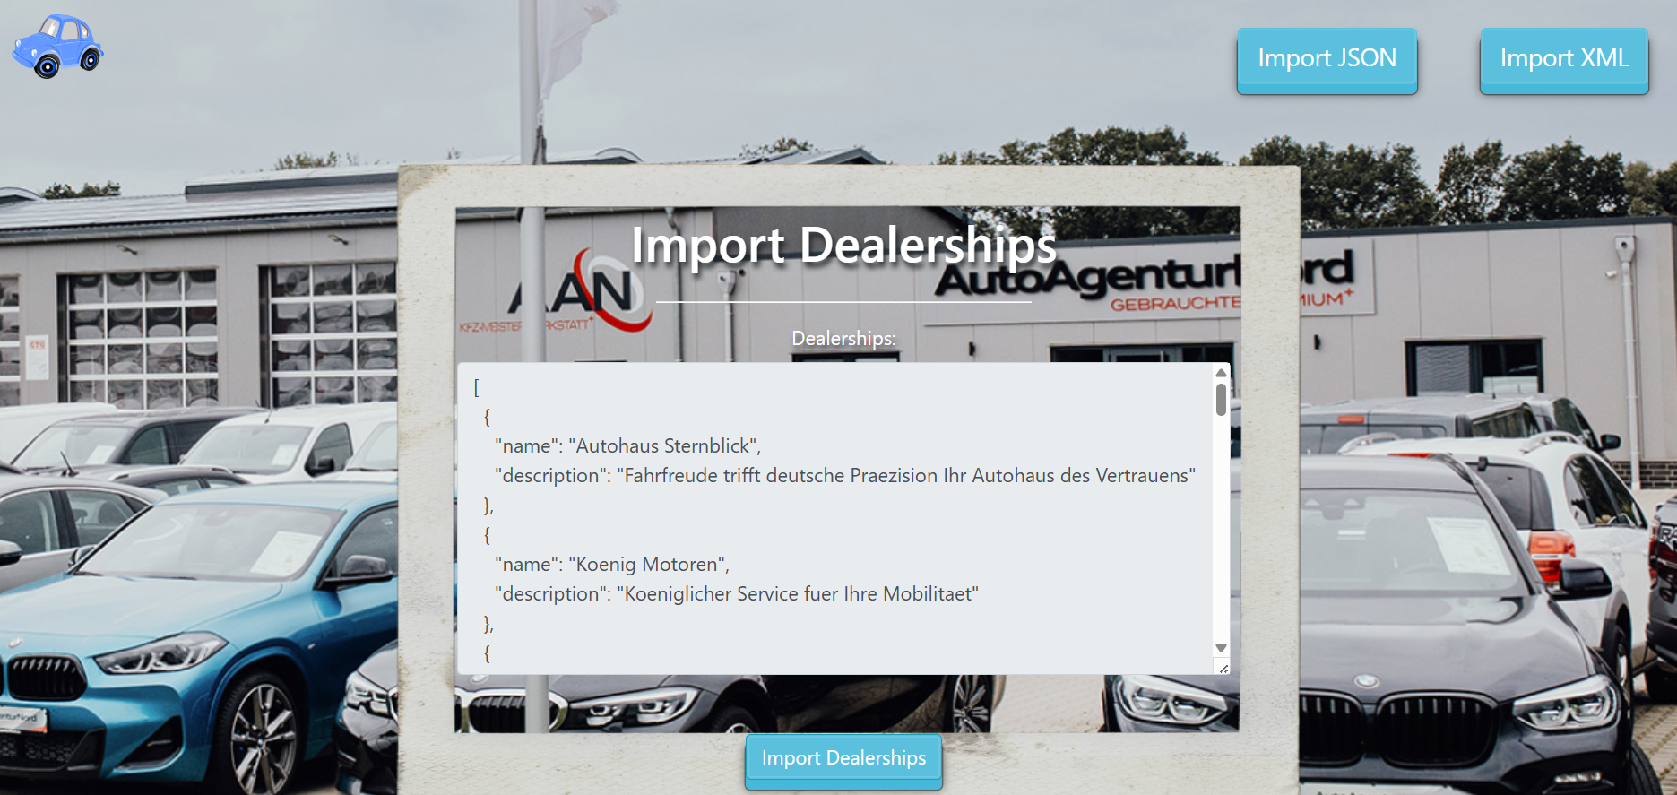

* Import the cars second:

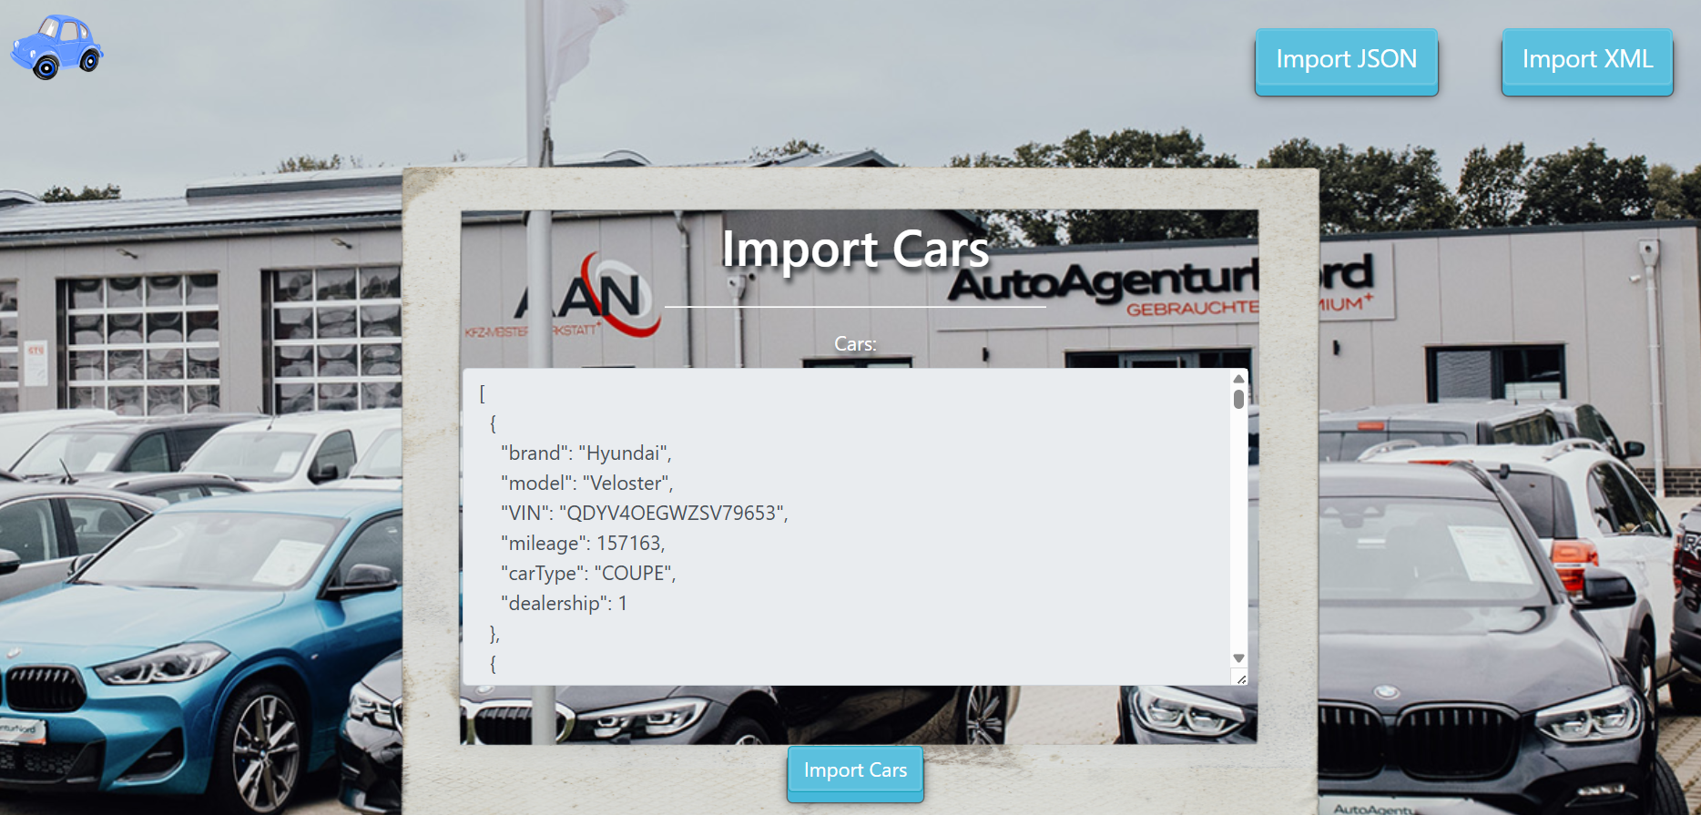

* The import JSON page after importing both files:

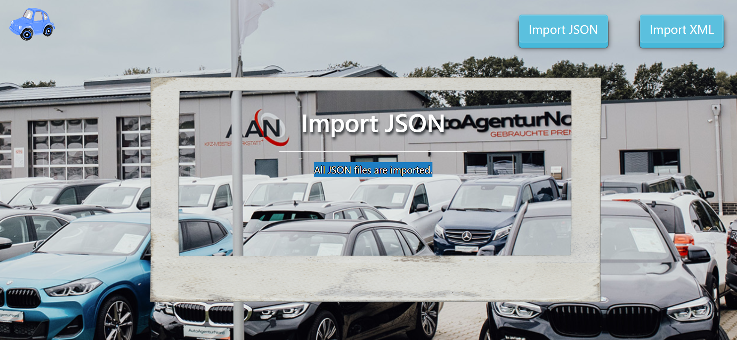

* The import XML page before importing the given data:

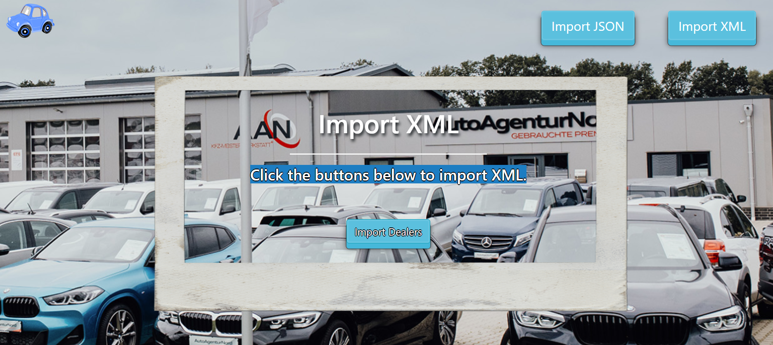

* Import the dealers data:

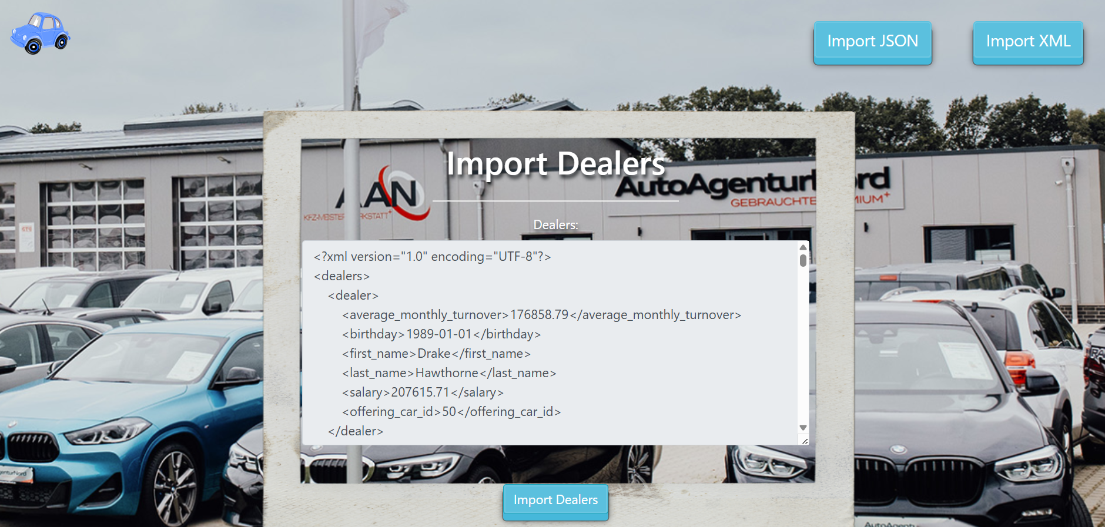

* After the XML import you will be redirected to home page and you will be able to export the cars using the “Export cars” button:



* Export all cars by type "COMBI" and mileage under 100000 km.:

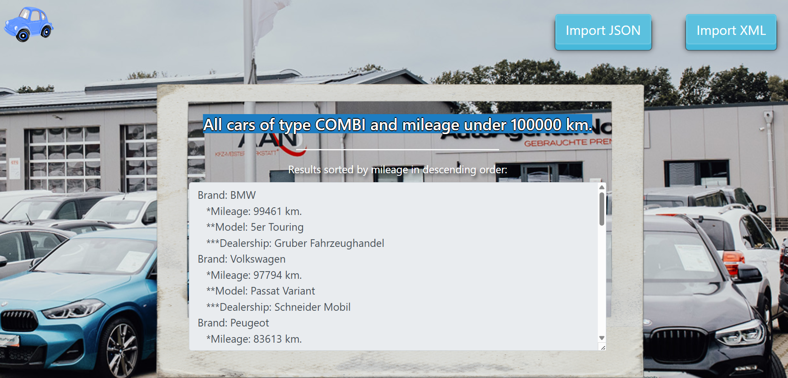

## Project Skeleton Overview

You will be given a **skeleton**, containing a **certain architecture (MVC)** with **several classes**, some of which are completely empty. The **Skeleton** will include the **files** with which you will **seed** the **database**.

**Don't change the skeleton.**

When **submit**ting your project in Judge please make a **.zip** file only with **src** folder and **pom.xml** file.  
There are five problems in **Judge**:

**1. Database** will test the structure of your database.

**2. Service** will test the two methods **areImported()** and **readClassFromFile()** in every service class.  
**3. Import JSON** will test the logic of importing **JSON** files.

**4. Import XML** will test the logic of importing **XML** files.

**5. Export** will test the logic of the final **export** button which is in the **ExportController**.

Please note that the automated system Judge may take up to **5 minutes** to show results for each problem. We kindly ask you to be patient.

Be aware that Jude might **not** recognize the **var** keyword, leading to compilation errors.

To help you ensure the correctness of your solutions and **gain immediate feedback**, we have included a set of **commented-out tests** within the provided skeleton project. These tests are designed to verify the functionality of the tasks you are required to implement.

## Model Definition

There are 3 main models that the **Deutsche Autohaeser database** application should contain in its functionality.

We have provided you with an Entity-Relationship (ER) diagram that represents the database schema. The ER diagram displays the tables and their relationships, along with the field types for each table.

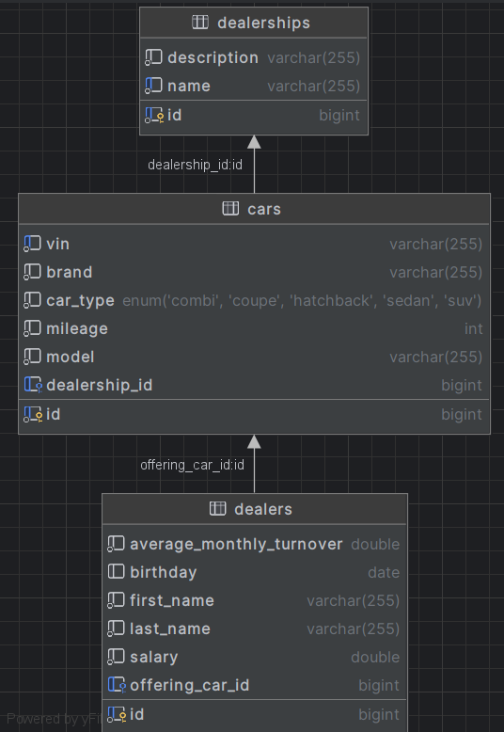

Ensure that the **Java** code **validates** data against the specified constraints before persisting it into the database. Handle any validation errors gracefully and provide meaningful feedback to the users.

Design them in the **most appropriate** way, considering the following **data constraints**:

#### Constraint

* Name the entities and their class members **exactly** in the **format stated** above.
* **All fields** are **NOT NULL** unless explicitly stated to be nullable.

### Dealership

* id – accepts **integer** values; it is the **primary identifier** and is **auto-incremented**.
* name – accepts **char sequence** (between **3** to **30** inclusive). The values are **unique in the database**.
* **description** - accepts **char** **sequence** about the naming of the dealership with a character length value higher than or equal to **5**.
* **cars** – a collection of all cars that are part the dealership

Constraint: The dealerships table has a relation with the cars table.

### Car

* id – accepts **integer** values; it is the **primary identifier** and is **auto-incremented**.
* brand - accepts **char** **sequence** (between **2** to **30** inclusive).
* model - accepts **char** **sequence** (between **2** to **30** inclusive).
* **VIN** – **char** **sequence** consisting of exactly **17** symbols (letters and numbers). The values are **unique in the database**
* mileage - The mileage in km. Accepts only positive number.
* car type - categorization of the cars. String enumeration, one of the following – **SUV, COMBI, COUPE, HATCHBACK, SEDAN**
* **dealership** – reference to the dealership that offers this car for sale.

Constraint: The cars table has a relation with the dealerships table.

### Dealer

* id – accepts **integer** values; it is the **primary identifier** and is **auto-incremented**.
* first name - accepts **char** **sequence** (between **2** to **30** inclusive).
* last name - accepts **char** **sequence** (between **2** to **30** inclusive).
* salary - accepts positive number values.
* average monthly turnover - accepts positive number values.
* birthday - a date in the "**yyyy-MM-dd**" format. Can be nullable.
* offering car - the current car that the dealer is offering.

Constraint: The dealers table has a relation with cars table.

### Relationships

Your partners gave you a little hint about the more complex relationships in the database, so that you can implement it correctly.

One **Dealer** may offer only one **Car**, but one **Car** may be offered by many **Dealers**.

One **Dealership** can have many **Cars**, but one **Car** belongs to only one **Dealership**.

## Data Import

Use the provided files to populate the database with data. Import all the information from those files into the database.

**You are not allowed to modify the provided files.**

**ANY INCORRECT** data should be **ignored** and a message should be printed:

**"Invalid {dealership / car / dealer}"**

**When the import is finished:**

**"Successfully imported {dealership / car / dealer} {name / brand – mileage km. / full name}"**

**Judge** will only accept **file paths** in a specific format. When dealing with file paths for files, please adhere to the following **format: "src/main/resources/files/xml/file-name.xml"**

### JSON Import

Your new colleagues have prepared some JSON data for you to import.

#### Dealerships (dealerships.json)

##### Constraint

**If a dealership with the same name already exists in the DB return "Invalid dealership".**

**If the import is successful, return "Successfully imported dealership {name}".**

|  |
| --- |
| **Dealership (dealerships.json)** |
| [  {  "name": "Autohaus Sternblick",  "description": "Fahrfreude trifft deutsche Praezision Ihr Autohaus des Vertrauens"  },  {  "name": "Koenig Motoren",  "description": "Koeniglicher Service fuer Ihre Mobilitaet"  },  {  "name": "Koenig Motoren",  "description": "Koeniglicher Service fuer Ihre Mobilitaet"  },  {  "name": "Autotechnik Bergmann",  "description": "Tradition trifft Innovation Ihr Partner fuer Qualitaet"  },  {  "name": "Meisterwagen Lichtenfeld",  "description": "Exklusive Fahrzeuge Persoenliche Beratung Faire Preise"  },  {  "name": "Fahrzeugwelt Neumann",  "description": "Entdecken Sie unsere Welt der Automobile"  },  {  "name": "Autozentrum Falkenstein",  "description": "Stark wie ein Falke Ihr Auto in besten Haenden"  },  ... |
| Successfully imported dealership Autohaus Sternblick  Successfully imported dealership Koenig Motoren  Invalid dealership  Successfully imported dealership Autotechnik Bergmann  Successfully imported dealership Meisterwagen Lichtenfeld  Successfully imported dealership Fahrzeugwelt Neumann  Successfully imported dealership Autozentrum Falkenstein… |

#### Cars (cars.json)

##### Constraint

* **If a car with the same VIN number already exists in the DB return "Invalid car".**
* **If the import is successful, return "Successfully imported car {brand} – {mileage} km."**

**The provided dealership ids will always be valid.**

|  |
| --- |
| **Car (cars.json)** |
| [  {  "brand": "Hyundai",  "model": "Veloster",  "VIN": "QDYV4OEGWZSV79653",  "mileage": 157163,  "carType": "COUPE",  "dealership": 1  },  {  "brand": "Hyundai",  "model": "Veloster",  "VIN": "QDYV4OEGWZSV79653",  "mileage": 157163,  "carType": "COUPE",  "dealership": 1  },  {  "brand": "Skoda",  "model": "Scala",  "VIN": "I0QHZ8TNJBQA24ITV",  "mileage": 212014,  "carType": "HATCHBACK",  "dealership": 18  },  {  "brand": "Volkswagen",  "model": "Arteon",  "VIN": "8R7W1WGAAZHH737H4",  "mileage": 38437,  "carType": "SEDAN",  "dealership": 16  },  {  "brand": "Skoda",  "model": "Kodiaq",  "VIN": "QDBQEYETK896Z9PZ6",  "mileage": 193030,  "carType": "SUV",  "dealership": 3  },    ... |
| Successfully imported car Hyundai - 157163 km.  Invalid car  Successfully imported car Skoda - 212014 km.  Successfully imported car Volkswagen - 38437 km.  Successfully imported car Skoda - 193030 km.  … |

### XML Import

Your new colleagues have prepared some XML data for you to import.

#### Dealers (dealers.xml)

##### Constraint

* **If a dealer with the same full name (first name and last name) already exists in the DB return "Invalid dealer".**
* **If a dealer is offering car that doesn't exist in the DB return "Invalid dealer ".**
* **If the import is successful, return "Successfully imported dealer {first name} {last name}".**

|  |
| --- |
| **Dealers (dealers.xml)** |
| *<?*xml version="1.0" encoding="UTF-8"*?>* <dealers>  <dealer>  <average_monthly_turnover>176858.79</average_monthly_turnover>  <birthday>1989-01-01</birthday>  <first_name>Drake</first_name>  <last_name>Hawthorne</last_name>  <salary>207615.71</salary>  <offering_car_id>50</offering_car_id>  </dealer>  <dealer>  <average_monthly_turnover>300.79</average_monthly_turnover>  <birthday>1989-01-01</birthday>  <first_name>Drake</first_name>  <last_name>Hawthorne</last_name>  <salary>207615.71</salary>  <offering_car_id>50</offering_car_id>  </dealer>  <dealer>  <average_monthly_turnover>176858.79</average_monthly_turnover>  <birthday>1989-01-01</birthday>  <first_name>Drake</first_name>  <last_name>Hawthorne</last_name>  <salary>207615.71</salary>  <offering_car_id>50</offering_car_id>  </dealer>  <dealer>  <average_monthly_turnover>55537.43</average_monthly_turnover>  <birthday>1966-11-03</birthday>  <first_name>Elena</first_name>  <last_name>Sullivan</last_name>  <salary>98319.24</salary>  <offering_car_id>91</offering_car_id>  </dealer>  <dealer>  <average_monthly_turnover>105443.87</average_monthly_turnover>  <birthday>1954-09-02</birthday>  <first_name>Cassandra</first_name>  <last_name>Bellamy</last_name>  <salary>1499.52</salary>  <offering_car_id>28</offering_car_id>  </dealer>  . . . |
| Successfully imported dealer Drake Hawthorne  Invalid dealer  Invalid dealer  Successfully imported dealer Elena Sullivan  … |

Please **be aware** that due to variations in local settings on different computers, the representation of decimal numbers (Double) may differ. In some regions, the decimal separator is a comma (,), while in others, it is a dot (.).

**Judge** local settings represent **all decimal numbers using a dot (.)** as the decimal separator. ***Locale.US***

## Data Export

Get ready to export the data you have imported in the previous task. Here you will have some complex database querying. Export the data in the formats specified below.

### Export cars by car type and mileage from the Database

* Extract from the database, the **car brand, mileage, (to second digit after decimal point), model and dealership name**.
* **Filter only cars of type COMBI and mileage under 100000km. Order the results by mileage in descending order.**
* Return the information in this format:

**"Brand: {brand}**

**\*Mileage: {mileage} km.**

**\*\*Model: {model}**

**\*\*\*Dealership: {dealershipName}**

**. . ."**

